STEP 1 — Set common PowerShell variables
Start with:
$REGION = "ap-south-1"
$CLUSTER_NAME = "my-cluster"

$ACCOUNT_ID = aws sts get-caller-identity `
--query Account `
--output text

Verify:
$ACCOUNT_ID

Then confirm cluster:

aws eks describe-cluster `
--name $CLUSTER_NAME `
--region $REGION `
--query "{Status:cluster.status,Version:cluster.version}" `
--output table

Expected:
Status ACTIVE
Version 1.36

Check nodes:
kubectl get nodes
They should be:
Ready

STEP 2 — Make sure only QA and PROD namespaces exist for the application
Add environment labels:
kubectl label namespace qa environment=qa --overwrite
kubectl label namespace prod environment=prod --overwrite

Verify:
kubectl get ns --show-labels
You should have:
qa
prod

From now on:
qa → QA application
prod → Production application

STEP 3 — Verify the EKS cluster OIDC provider
OIDC Issuer
The OIDC issuer belongs to your EKS cluster.
Its job is essentially:
Issue/sign identity tokens for Kubernetes ServiceAccounts in this EKS cluster.

IAM OIDC Provider
The IAM OIDC Provider lives inside AWS IAM.
This registers the EKS cluster's issuer URL with IAM.
EKS OIDC Issuer
= produces/provides the identity

IAM OIDC Provider
= tells AWS IAM to trust that issuer

This is an important distinction.
You already configured GitHub OIDC for:
GitHub Actions
↓
AWS IAM
↓
EKS

Now we need EKS cluster OIDC for IRSA:
Kubernetes ServiceAccount
↓
EKS OIDC
↓
IAM Role
↓
AWS Secrets Manager

Your ALB setup already includes the cluster OIDC association command.
Check the cluster issuer:
$OIDC_ISSUER = aws eks describe-cluster `
--name $CLUSTER_NAME `
--region $REGION `
--query "cluster.identity.oidc.issuer" `
--output text

Check:
$OIDC_ISSUER
You'll get something similar to:
https://oidc.eks.ap-south-1.amazonaws.com/id/XXXXXXXXXXXX

Its main purpose is to let Kubernetes workloads inside EKS assume AWS IAM roles, traditionally through IRSA (IAM Roles for Service Accounts). AWS states that every EKS cluster has an OIDC issuer URL, and an IAM OIDC provider can be created from it for IRSA.
Then verify the IAM provider.
Get the ID:
$OIDC_ID = ($OIDC_ISSUER -split "/")[-1]
Run:
aws iam list-open-id-connect-providers `
--query "OpenIDConnectProviderList[?contains(Arn, '$OIDC_ID')].Arn" `
--output text

If you get an ARN, you're done.
If nothing comes back:
eksctl utils associate-iam-oidc-provider `
--cluster $CLUSTER_NAME `
--region $REGION `
--approve

IRSA uses this EKS-specific OIDC provider to map IAM roles to Kubernetes ServiceAccounts.

STEP 4 — Install Amazon EBS CSI Driver
This is required before MySQL persistent storage.
Architecture:
MySQL
↓
PVC
↓
StorageClass
↓
EBS CSI Driver
↓
AWS EBS

Check if exists:
aws iam get-role `
--role-name AmazonEKS_EBS_CSI_DriverRole `
--query "Role.Arn" `
--output text

First create the IAM role:
eksctl create iamserviceaccount `
--name ebs-csi-controller-sa `
--namespace kube-system `
--cluster $CLUSTER_NAME `
--region $REGION `
--role-name AmazonEKS_EBS_CSI_DriverRole `
--role-only `
--attach-policy-arn arn:aws:iam::aws:policy/AmazonEBSCSIDriverPolicyV2 `
--approve

This command creates the IAM role for the EBS CSI Driver and attaches the AWS permissions required to manage EBS volumes. --role-only means eksctl creates the IAM role but leaves creation/management of ebs-csi-controller-sa to the EKS add-on.

Verify:
aws iam get-role `
--role-name AmazonEKS_EBS_CSI_DriverRole `
--query "Role.Arn" `
--output text

Set:
$EBS_ROLE_ARN = "arn:aws:iam::${ACCOUNT_ID}:role/AmazonEKS_EBS_CSI_DriverRole"
An EKS add-on is basically extra operational software installed in your EKS cluster to provide a specific capability.
It is not your application. It supports the cluster.

EKS Cluster
|
+-- CoreDNS add-on
| → DNS inside Kubernetes
|
+-- VPC CNI add-on
| → Pod networking
|
+-- EBS CSI Driver add-on
→ Persistent EBS storage

EBS CSI Driver = The actual software that lets Kubernetes
communicate with AWS EBS.

Whereas:

EKS Add-on = AWS's managed way of installing and managing
that software inside an EKS cluster.

Check whether the add-on already exists:
aws eks describe-addon `
--cluster-name $CLUSTER_NAME `
--region $REGION `
--addon-name aws-ebs-csi-driver

If it doesn't exist:
aws eks create-addon `
--cluster-name $CLUSTER_NAME `
--region $REGION `
--addon-name aws-ebs-csi-driver `
--service-account-role-arn $EBS_ROLE_ARN

If it already exists:
aws eks update-addon `
--cluster-name $CLUSTER_NAME `
--region $REGION `
--addon-name aws-ebs-csi-driver `
--service-account-role-arn $EBS_ROLE_ARN `
--resolve-conflicts OVERWRITE

Verify:
kubectl get pods -n kube-system |
Select-String ebs-csi

You should see controller and node components running.
The EBS CSI driver supports dynamic provisioning, meaning a PVC can cause an EBS volume and corresponding PV to be created automatically.

STEP 5 — Create StorageClasses
StorageClass = The Kubernetes configuration that says WHAT type of storage should be created.
EBS CSI Driver = The actual software that talks to AWS and CREATES/MANAGES that EBS volume.

Create:
k8-manifests/
└── cluster-infra/
└── storageclasses.yaml

Use:
apiVersion: storage.k8s.io/v1
kind: StorageClass
metadata:
name: ebs-gp3-qa
provisioner: ebs.csi.aws.com
parameters:
type: gp3
encrypted: "true"
volumeBindingMode: WaitForFirstConsumer
allowVolumeExpansion: true
reclaimPolicy: Delete

---
apiVersion: storage.k8s.io/v1
kind: StorageClass
metadata:
name: ebs-gp3-prod
provisioner: ebs.csi.aws.com
parameters:
type: gp3
encrypted: "true"
volumeBindingMode: WaitForFirstConsumer
allowVolumeExpansion: true
reclaimPolicy: Retain

Apply this using your administrator account, not the namespace-scoped GitHub deployment role:
kubectl apply -f .\k8-manifests\cluster-infra\storageclasses.yaml
Verify:
kubectl get storageclass
Expected:
ebs-gp3-qa
ebs-gp3-prod

ebs-gp3-qa
→ gp3 EBS volume
→ encrypted
→ volume created only when a Pod actually needs it
→ PVC can be expanded
→ reclaimPolicy: Delete
→ deleting the PVC can delete the EBS volume

ebs-gp3-prod
→ gp3 EBS volume
→ encrypted
→ WaitForFirstConsumer
→ expandable
→ reclaimPolicy: Retain
→ EBS volume is kept even if the PVC is deleted

The reason for two classes is mostly lifecycle:
QA
Delete PVC/PV
↓
EBS can be deleted

PROD
Delete PVC/PV
↓
EBS retained

WaitForFirstConsumer is useful for EBS because the volume is AZ-specific and should be provisioned after Kubernetes knows where the consuming Pod will run.

STEP 6 — Install External Secrets Operator
Now we connect Kubernetes to AWS Secrets Manager.
An External Secrets Operator (ESO) is a Kubernetes controller that reads secrets from an external secret manager like AWS Secrets Manager and creates/updates normal Kubernetes Secrets from them.
We are going to use:
AWS Secrets Manager
↓
External Secrets Operator
↓
Kubernetes Secret
External Secrets Operator = The software/controller that does the work

SecretStore
→ tells ESO WHERE/HOW to connect
to AWS Secrets Manager

ExternalSecret
→ tells ESO WHICH secret to fetch

Kubernetes Secret
→ actual Secret created by ESO
and consumed by your Pod

The latest External Secrets release is currently v2.11.0.
Install:
helm repo add external-secrets `
https://charts.external-secrets.io

Then:
helm repo update
Install:
helm upgrade --install external-secrets `
external-secrets/external-secrets `
--namespace external-secrets `
--create-namespace `
--version 2.11.0 `
--set installCRDs=true

Verify:
kubectl get pods -n external-secrets
You should see External Secrets components running.
Check CRDs:
kubectl get crds |
Select-String external-secrets

External Secrets uses SecretStore and ExternalSecret resources to sync an external provider such as AWS Secrets Manager into Kubernetes Secrets.

STEP 7 — Create QA database secret in AWS Secrets Manager
Go to:
AWS Console
→ Secrets Manager
→ Store a new secret

Choose:
Other type of secret
Add:
MYSQL_ROOT_PASSWORD
MYSQL_USER
MYSQL_PASSWORD

For QA, for example:
MYSQL_ROOT_PASSWORD = <strong-qa-root-password>
MYSQL_USER = projectops_qa
MYSQL_PASSWORD = <strong-qa-app-password>

Secret name:
projectops/qa/mysql
Create it.
Verify only metadata:
aws secretsmanager describe-secret `
--secret-id projectops/qa/mysql `
--region $REGION

STEP 8 — Create PROD database secret
Same process.
Values:
MYSQL_ROOT_PASSWORD = <strong-prod-root-password>
MYSQL_USER = projectops_prod
MYSQL_PASSWORD = <strong-prod-app-password>

Secret name:
projectops/prod/mysql
Verify:
aws secretsmanager describe-secret `
--secret-id projectops/prod/mysql `
--region $REGION

Now AWS has:
Secrets Manager
│
├── projectops/qa/mysql
│
└── projectops/prod/mysql

STEP 9 — Create QA IAM policy for Secrets Manager
Create:
@"
{
"Version":"2012-10-17",
"Statement":[
{
"Effect":"Allow",
"Action":[
"secretsmanager:GetSecretValue",
"secretsmanager:DescribeSecret"
],
"Resource":"arn:aws:secretsmanager:${REGION}:${ACCOUNT_ID}:secret:projectops/qa/mysql-*"
}
]
}
"@ | Out-File `
-FilePath .\eso-qa-policy.json `
-Encoding ascii

Create policy:
aws iam create-policy `
--policy-name ESOProjectOpsQASecretsRead `
--policy-document file://eso-qa-policy.json

Get ARN:
$QA_SECRET_POLICY_ARN = aws iam list-policies `
--scope Local `
--query "Policies[?PolicyName=='ESOProjectOpsQASecretsRead'].Arn" `
--output text

Check:
$QA_SECRET_POLICY_ARN

STEP 10 — Create PROD IAM policy
Create:
@"
{
"Version":"2012-10-17",
"Statement":[
{
"Effect":"Allow",
"Action":[
"secretsmanager:GetSecretValue",
"secretsmanager:DescribeSecret"
],
"Resource":"arn:aws:secretsmanager:${REGION}:${ACCOUNT_ID}:secret:projectops/prod/mysql-*"
}
]
}
"@ | Out-File `
-FilePath .\eso-prod-policy.json `
-Encoding ascii

Create:
aws iam create-policy `
--policy-name ESOProjectOpsProdSecretsRead `
--policy-document file://eso-prod-policy.json

Get ARN:
$PROD_SECRET_POLICY_ARN = aws iam list-policies `
--scope Local `
--query "Policies[?PolicyName=='ESOProjectOpsProdSecretsRead'].Arn" `
--output text

STEP 11 — Create QA and PROD IRSA ServiceAccounts
This is where Kubernetes ServiceAccounts are required.
Important:
These ServiceAccounts are not for GitHub OIDC.
They are specifically for:
External Secrets Operator
↓
AWS Secrets Manager

External Secrets officially supports EKS ServiceAccount credentials using auth.jwt.serviceAccountRef.
Create QA:
eksctl create iamserviceaccount `
--name eso-qa-sa `
--namespace qa `
--cluster $CLUSTER_NAME `
--region $REGION `
--role-name eso-qa-secrets-role `
--attach-policy-arn $QA_SECRET_POLICY_ARN `
--approve

Create PROD:
eksctl create iamserviceaccount `
--name eso-prod-sa `
--namespace prod `
--cluster $CLUSTER_NAME `
--region $REGION `
--role-name eso-prod-secrets-role `
--attach-policy-arn $PROD_SECRET_POLICY_ARN `
--approve

Verify:
kubectl get sa eso-qa-sa -n qa
kubectl get sa eso-prod-sa -n prod

Describe QA:
kubectl describe sa eso-qa-sa -n qa
You should see an annotation containing an IAM role.
Same for PROD:
kubectl describe sa eso-prod-sa -n prod
The important separation is:
eso-qa-sa
↓
Can read only projectops/qa/mysql
and:
eso-prod-sa
↓
Can read only projectops/prod/mysql

AWS Secrets Manager
↓
stores the REAL secret values
↓
SecretStore
↓
tells ESO:
"Use AWS Secrets Manager in ap-south-1
and authenticate using this ServiceAccount"
↓
ExternalSecret
↓
tells ESO:
"Fetch THESE specific keys
from THIS AWS secret"
↓
External Secrets Operator
↓
actually performs the fetch/sync
↓
Kubernetes Secret
↓
Pod reads the secret
as environment variables

AWS Secrets Manager
= Stores actual passwords/secrets

ServiceAccount + IAM Role
= Gives permission to read AWS Secrets Manager

SecretStore
= WHERE to get secrets from + HOW to authenticate

ExternalSecret
= WHICH secret/keys to fetch

External Secrets Operator
= The controller that does the actual syncing

Kubernetes Secret
= Local Kubernetes copy created by ESO

Pod
= Consumes the Kubernetes Secret

STEP 12 — Create directory structure
Now create:
k8-manifests/
│
├── cluster-infra/
│ └── storageclasses.yaml
│
├── qa/
│ ├── mysql-config.yaml
│ ├── secret-store.yaml
│ ├── external-secret.yaml
│ ├── mysql-service.yaml
│ └── mysql-statefulset.yaml
│
└── prod/
├── mysql-config.yaml
├── secret-store.yaml
├── external-secret.yaml
├── mysql-service.yaml
└── mysql-statefulset.yaml

Later we add backend, frontend and Ingress to these same directories.

STEP 13 — QA MySQL ConfigMap
Create:
k8-manifests/qa/mysql-config.yaml
apiVersion: v1
kind: ConfigMap
metadata:
name: mysql-config
namespace: qa
data:
MYSQL_DATABASE: projectops
DB_URL: jdbc:mysql://mysql:3306/projectops?useSSL=false&allowPublicKeyRetrieval=true&serverTimezone=UTC

Why ConfigMap?
Because:
Database name
Database hostname
Database URL

are configuration, not passwords.

STEP 14 — QA SecretStore
Create:
k8-manifests/qa/secret-store.yaml
apiVersion: external-secrets.io/v1
kind: SecretStore
metadata:
name: aws-secretsmanager
namespace: qa
spec:
provider:
aws:
service: SecretsManager
region: ap-south-1
auth:
jwt:
serviceAccountRef:
name: eso-qa-sa

This tells External Secrets:
Use AWS Secrets Manager
Region = ap-south-1
Authenticate using eso-qa-sa

STEP 15 — QA ExternalSecret
Create:
k8-manifests/qa/external-secret.yaml
apiVersion: external-secrets.io/v1
kind: ExternalSecret
metadata:
name: mysql-external-secret
namespace: qa
spec:
refreshInterval: 1h

secretStoreRef:
name: aws-secretsmanager
kind: SecretStore

target:
name: mysql-secret
creationPolicy: Owner

data:
- secretKey: MYSQL_ROOT_PASSWORD
remoteRef:
key: projectops/qa/mysql
property: MYSQL_ROOT_PASSWORD

- secretKey: MYSQL_USER
remoteRef:
key: projectops/qa/mysql
property: MYSQL_USER

- secretKey: MYSQL_PASSWORD
remoteRef:
key: projectops/qa/mysql
property: MYSQL_PASSWORD

property = key to read from AWS Secrets Manager.
secretKey = key name to create inside the Kubernetes Secret.

The result will be:
AWS Secrets Manager
projectops/qa/mysql
↓
ExternalSecret
↓
Kubernetes Secret
mysql-secret

STEP 16 — QA MySQL Services
Create:
k8-manifests/qa/mysql-service.yaml
apiVersion: v1
kind: Service
metadata:
name: mysql-headless
namespace: qa
spec:
clusterIP: None
selector:
app: mysql
ports:
- name: mysql
port: 3306
targetPort: mysql

---
apiVersion: v1
kind: Service
metadata:
name: mysql
namespace: qa
spec:
type: ClusterIP
selector:
app: mysql
ports:
- name: mysql
port: 3306
targetPort: mysql

Why two Services?
mysql-headless
→ StatefulSet network identity

mysql-0.mysql-headless.qa.svc.cluster.local
mysql-1.mysql-headless.qa.svc.cluster.local
mysql-2.mysql-headless.qa.svc.cluster.local

mysql
→ stable service used by backend

The backend will connect to:
mysql:3306
The headless Service is mainly what gives that Pod a stable DNS address:
Pod name:
mysql-0

Headless Service:
mysql-headless

Stable DNS:
mysql-0.mysql-headless

StatefulSet
→ creates stable Pod names
mysql-0, mysql-1, mysql-2

ClusterIP Service
→ one common address
mysql:3306
→ routes to any matching Pod

Headless Service
→ no ClusterIP
→ gives direct DNS for each Pod

mysql-0.mysql-headless
mysql-1.mysql-headless
mysql-2.mysql-headless

So:
ClusterIP = one address for the whole group.
Headless = direct address for each individual Pod.

STEP 17 — QA MySQL StatefulSet
Create:
k8-manifests/qa/mysql-statefulset.yaml
apiVersion: apps/v1
kind: StatefulSet
metadata:
name: mysql
namespace: qa

spec:
serviceName: mysql-headless

replicas: 1

selector:
matchLabels:
app: mysql

template:
metadata:
labels:
app: mysql
environment: qa

spec:
terminationGracePeriodSeconds: 60

securityContext:
runAsNonRoot: true
runAsUser: 999
runAsGroup: 999
fsGroup: 999
seccompProfile:
type: RuntimeDefault

containers:
- name: mysql

image: mysql:8.4.11

ports:
- name: mysql
containerPort: 3306

env:
- name: MYSQL_DATABASE
valueFrom:
configMapKeyRef:
name: mysql-config
key: MYSQL_DATABASE

- name: MYSQL_ROOT_PASSWORD
valueFrom:
secretKeyRef:
name: mysql-secret
key: MYSQL_ROOT_PASSWORD

- name: MYSQL_USER
valueFrom:
secretKeyRef:
name: mysql-secret
key: MYSQL_USER

- name: MYSQL_PASSWORD
valueFrom:
secretKeyRef:
name: mysql-secret
key: MYSQL_PASSWORD

resources:
requests:
cpu: "250m"
memory: "512Mi"

limits:
cpu: "1"
memory: "1Gi"

securityContext:
allowPrivilegeEscalation: false
capabilities:
drop:
- ALL

startupProbe:
exec:
command:
- /bin/sh
- -c
- mysqladmin ping -h 127.0.0.1 --silent

periodSeconds: 5
timeoutSeconds: 3
failureThreshold: 30

readinessProbe:
exec:
command:
- /bin/sh
- -c
- mysqladmin ping -h 127.0.0.1 --silent

periodSeconds: 10
timeoutSeconds: 3
failureThreshold: 3

livenessProbe:
exec:
command:
- /bin/sh
- -c
- mysqladmin ping -h 127.0.0.1 --silent

periodSeconds: 20
timeoutSeconds: 3
failureThreshold: 3

volumeMounts:
- name: mysql-storage
mountPath: /var/lib/mysql

volumeClaimTemplates:
- metadata:
name: mysql-storage

spec:
storageClassName: ebs-gp3-qa

accessModes:
- ReadWriteOnce

resources:
requests:
storage: 5Gi

ReadWriteOnce (RWO) means the volume can be mounted with read and write access by one Kubernetes node at a time.
- Multiple Pods on that same node can use the volume.
- It does not mean only one Pod can use it.
Notice:
There is no separate PV YAML.
And there isn't even a separate PVC YAML here.
The StatefulSet automatically creates:
mysql-storage-mysql-0
as the PVC.
Then:
PVC
↓
StorageClass
↓
EBS CSI Driver
↓
EBS
↓
PV

STEP 18 — Deploy QA secrets first
Do this before MySQL.
kubectl apply -f .\k8-manifests\qa\mysql-config.yaml
kubectl apply -f .\k8-manifests\qa\secret-store.yaml
kubectl apply -f .\k8-manifests\qa\external-secret.yaml
Verify:
kubectl get secretstore -n qa
Then:
kubectl get externalsecret -n qa
Expected:
READY
True

Then:
kubectl get secret mysql-secret -n qa
Do not decode the secret in normal demonstrations.

STEP 19 — Deploy QA MySQL
kubectl apply -f .\k8-manifests\qa\mysql-service.yaml
Then:
kubectl apply -f .\k8-manifests\qa\mysql-statefulset.yaml
Watch:
kubectl get pods -n qa -w
Eventually:
mysql-0 1/1 Running
Check PVC:
kubectl get pvc -n qa
Expected:
mysql-storage-mysql-0 Bound
Check PV:
kubectl get pv
Get actual EBS volume:
$QA_PV = kubectl get pvc mysql-storage-mysql-0 `
-n qa `
-o jsonpath='{.spec.volumeName}'

Then:
kubectl get pv $QA_PV `
-o jsonpath='{.spec.csi.volumeHandle}'

You'll receive something like:
vol-xxxxxxxxxxxxxxxx
That is the AWS EBS volume.

STEP 20 — Create PROD files
The PROD files are nearly identical.
Only change:
namespace:
qa → prod

Secret:
projectops/qa/mysql
→
projectops/prod/mysql

ServiceAccount:
eso-qa-sa
→
eso-prod-sa

StorageClass:
ebs-gp3-qa
→
ebs-gp3-prod

Storage:
5Gi
→
10Gi

Resources should also be slightly higher.
For PROD MySQL:
resources:
requests:
cpu: "500m"
memory: "1Gi"

limits:
cpu: "2"
memory: "2Gi"
Everything else can remain the same.

STEP 21 — Deploy PROD
Apply configuration:
kubectl apply -f .\k8-manifests\prod\mysql-config.yaml
kubectl apply -f .\k8-manifests\prod\secret-store.yaml
kubectl apply -f .\k8-manifests\prod\external-secret.yaml
Check:
kubectl get externalsecret -n prod
Then deploy MySQL:
kubectl apply -f .\k8-manifests\prod\mysql-service.yaml
kubectl apply -f .\k8-manifests\prod\mysql-statefulset.yaml

Verify:
kubectl get pods -n prod
kubectl get svc -n prod
kubectl get pvc -n prod

Expected:
mysql-0 Running
and PVC:
Bound

STEP 22 — Final database verification
QA:
kubectl get all -n qa
kubectl get pvc -n qa
kubectl get externalsecret -n qa
kubectl get secret mysql-secret -n qa

PROD:
kubectl get all -n prod
kubectl get pvc -n prod
kubectl get externalsecret -n prod
kubectl get secret mysql-secret -n prod

Check MySQL logs:
kubectl logs mysql-0 -n qa
and:
kubectl logs mysql-0 -n prod
At this stage your architecture should be:
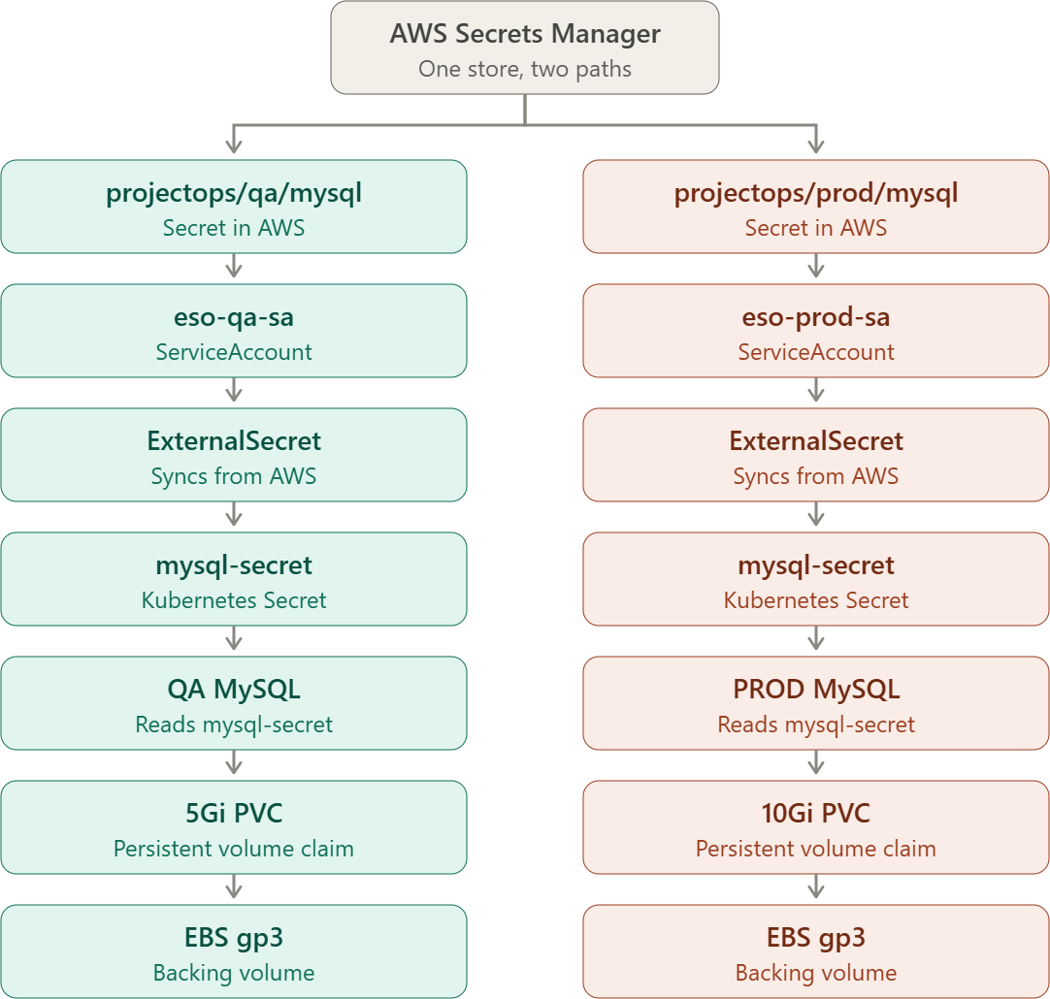

So the immediate task now is Steps 1–22 only: get EBS CSI + StorageClasses + Secrets Manager + External Secrets + QA MySQL + PROD MySQL completely working. Once both mysql-0 Pods are Running, both PVCs are Bound, and both ExternalSecret objects show READY=True, then move to backend/frontend/Ingress.

